**SMALL BUSINESS NETWORK DESIGN**

**WITH SECURE E-COMMERCE SERVER**

**A PROJECT REPORT**

Submitted by

SANSKRITI SHRIVASTAVA [RA1811031010048]

**Under the guidance of**

**Dr. Mukeshkrishnan MB**

in partial fulfillment for the award of the degree

**of**

**BACHELOR OF TECHNOLOGY**

**in**

**COMPUTER SCIENCE & ENGINEERING**

**of**

**FACULTY OF ENGINEERING AND TECHNOLOGY**



**S.R.M. Nagar, Kattankulathur, Kancheepuram District**

**NOVEMBER 2020**

**SRM INSTITUTE OF SCIENCE AND TECHNOLOGY**

**(Under Section 3 of UGC Act, 1956)**

**BONAFIDE CERTIFICATE**

Certified that this project report titled “SMALL BUSINESS NETWORK DESIGN

WITH SECURE E-COMMERCE SERVER” is the bonafide

work of “**SANSKRITI SHRIVASTAVA [RA1811031010048]**”, who

carried out the project work under my supervision. Certified further, that

to the best of my knowledge the work reported herein does not form

any other project report or dissertation on the basis of which a degree or

award was conferred on an earlier occasion on this or any other candi-

date.

**SIGNATURE**

**Dr. Mukeshkrishnan MB**

**GUIDE**

**Associate Professor**

**Dept. of Computer Science & Engineering**

**Signature of the Internal Examiner**

**TABLE OF CONTENTS**

1. Abstract
2. Objective
3. Introduction
4. Modules of the Project:

* Project Scope
* Requirements
* Requirements Analysis
* Network diagram
* TCP/IP table
* Router configuration
* Solution Explanation
* Hardware List

1. Calculations
2. Inference &Conclusion
3. References

**PROJECT TITLE:**

**SMALL BUSINESS NETWORK DESIGN**

**WITH SECURE E-COMMERCE SERVER**

**ABSTRACT**

A small network is often more susceptible to viruses and spyware than larger networks, due to software vulnerabilities. Up-to-date software built to manage these risks is just as important as having high quality routing systems and hardware. Security of e-commerce websites is essential for compliances laws and regulations as well as gaining and maintaining the trust of consumers, partners and stakeholders. Many security standards have been established by various organizations to help guide security of small business servers, however, many of those standards or guidelines are too costly or time consuming. Thus, I aim at designing a network for a small business with secure e-commerce.

**OBJECTIVE**

The goal of this project is to design a network for a small business organisation with a secure e-commerce application. Our objective is to keep the design simple yet effective which incurs less cost and higher throughput.

**INTRODUCTION**

For a small business organization with over 100 clients, a network is designed with a secure e-commerce server. The organization hosts an e-commerce application on a server which is accessible to internet users using https and with a public IP address. The e-commerce website is host on a web server which is accessed by the clients over the internet through ISP. The small organization has a small file server and mail server which is only accessible to the administrator of the company and not all corporate staff. For network security, we make use of the firewall, VPN’s, SSH, DHCP in the network design.

**MODULES OF THE PROJECT**

1. **Project Scope:**

A network has to be designed for a small business organization which has 100 users. The organization hosts an e-commerce application on a server which is accessible to internet users using https and with a public IP address.

1. **Requirements:**

Essentials requirements include : Computers/ laptop, external hard drives, network server solution, router, a quality printer, cables, firewalls , database server , web server, application server, public and private IP addresses,SSH services, DHCP services.

1. **Requirement Analysis:**
2. Computers/Laptops: To make requests, process them etc.
3. External Hard drives: Some computers in your network may need an external hard drive to store certain types of information.An external hard drive can be a wise investment for startup businesses that don’t want to store information in the Cloud or on their computers’ hard drives. External hard drives can protect valuable and sensitive business data in the event of an accident, such as a fire. We can use these as back-up devices for certain types of data and even invest in a system with built-in locks and extra layers of security to prevent theft.
4. Network Server Solution: If the business will need any type of network to support the database, email applications, and other files, we’ll need to set up a network server. We can choose from several server solutions based on the amount of storage we need, security requirements, and backup options.
5. Router: Keep the office or workspace connected to the Internet wirelessly with a wireless router. A strong wireless connection can ensure high-speed connectivity to all linked computers and mobile devices. A router is a networking device that forwards data packets between computer networks. Routers perform the traffic directing functions on the Internet.
6. Printer: plan to print out all of your marketing materials or just need to handle basic jobs, invest in high-quality printers for fast printing times and energy savings. Minimize printing costs by encouraging employees to work as a paperless office whenever possible. We will still need a good printer for contracts, legal documents, and other materials. Some printers have multiple functions including scanning, photocopying, and faxing.
7. Cables: For connections.
8. Firewalls: A firewall is a software or hardware configuration. The primary purpose of firewalls is to control inbound and outbound internal network traffic. It is supposed to grant or deny access to a private network. They can be used to restrict the system to limit services.
9. Database Server: A Database Server is a computer in a LAN that is dedicated to database storage and retrieval. It holds the Database Management System (DBMS) and the databases. When clients request for something, the data is searched by the server in the records and then a response is sent back to network.
10. Web Server: A web server is software and hardware that uses  and other protocols to respond to client requests made over the WWW The main job of a web server is to display website content through storing, processing and delivering webpages to users.
11. Application Server: To run the application/ execute the program.
12. IP addresses: IP address stands for internet protocol address; it is an identifying number that is associated with a specific computer or computer network. When connected to the internet, the IP address allows the computers to send and receive information.
13. SSH services: **SSH** or **Secure Shell** is a [cryptographic](https://en.wikipedia.org/wiki/Cryptography) [network protocol](https://en.wikipedia.org/wiki/Network_protocol) for operating network services securely over an unsecured network.[[1]](https://en.wikipedia.org/wiki/SSH_(Secure_Shell)#cite_note-rfc4251-1) Typical applications include remote [command-line](https://en.wikipedia.org/wiki/Command-line_interface), [login](https://en.wikipedia.org/wiki/Login), and remote command execution, but any [network service](https://en.wikipedia.org/wiki/Network_service) can be secured with SSH. SSH provides a [secure channel](https://en.wikipedia.org/wiki/Secure_channel) over an unsecured network by using a [client–server](https://en.wikipedia.org/wiki/Client%E2%80%93server_model) architecture, connecting an [SSH client](https://en.wikipedia.org/wiki/SSH_client) application with an [SSH server](https://en.wikipedia.org/wiki/SSH_server).
14. DHCP services: The DHCP(Dynamic Host Configuration Protocol) generates a new Public IP address, hiding the private IP address. It also configures the PC dynamically.
15. **Network Diagram: (roughly done)**

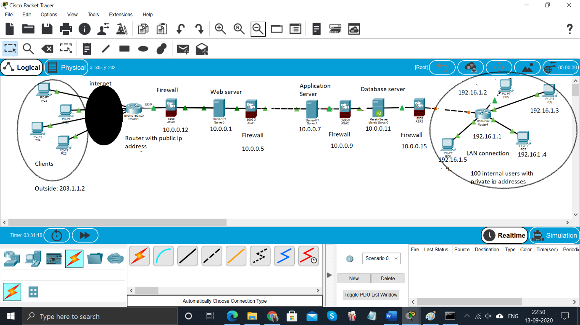

1. **TCP/IP Table:**

|  |  |
| --- | --- |
| Current Address | Next-hop Address |
| 192.168.56.1 | 203.1.1.2 |
| 203.1.1.2 | 10.0.0.12 |
| 10.0.0.12 | 10.0.0.1 |
| 10.0.0.1 | 10.0.0.5 |
| 10.0.0.5 | 10.0.0.7 |
| 10.0.0.7 | 10.0.0.9 |
| 10.0.0.9 | 10.0.0.11 |
| 10.0.0.11 | 10.0.0.15 |
| 10.0.1.15 | 192.16.1.1 |
| 172.16.1.1 | 172.16.1.3 (Supposed destination) |

1. **Router Configuration:**

Router>en

Router#conf t

Router (config)#host R1

R1(config)# int f0/0

R1(config)#ip address 192.16.1.1 255.255.255.0

R1(config)#no shut

1. **Solution Explanation:**

In this project, I have tried to design a rough network of a secure E-commerce website. Going from left to right in the diagram above, the internet traffic will originate from the clients’ electronic devices (PCs, phones etc), and land on the public router (with public ip address/203.1.1.2). The traffic will pass through a secure firewall through authorised ports and will hit the web server and the website landing page will be presented. Once the users do any transactions/ make request on the site, web server directs the traffic to the application server for execution. The application server will in turn connect with the data server through secured firewalls and data will be retrieved. The internal users connected via LAN and they can reach the Database servers internally using private internal IPs. The internal computers are connected to the rest of the world via WAN.

1. **Hardware List:**

* Computers/ laptop,
* external hard drives,
* router,
* a quality printer,
* cables,
* firewalls
* servers

**CALCULATIONS**

**(LAN connection internally in the organisation connecting 100 users)**

**Organisation (Internally connected) :**

Network Address: 192.16.1.0/25

First Host: 192.16.1.1/25

Last Host: 192.16.1.126/25

Broadcast Address: 192.16.1.127/25

WAN IP address: 192.16.1.128/25

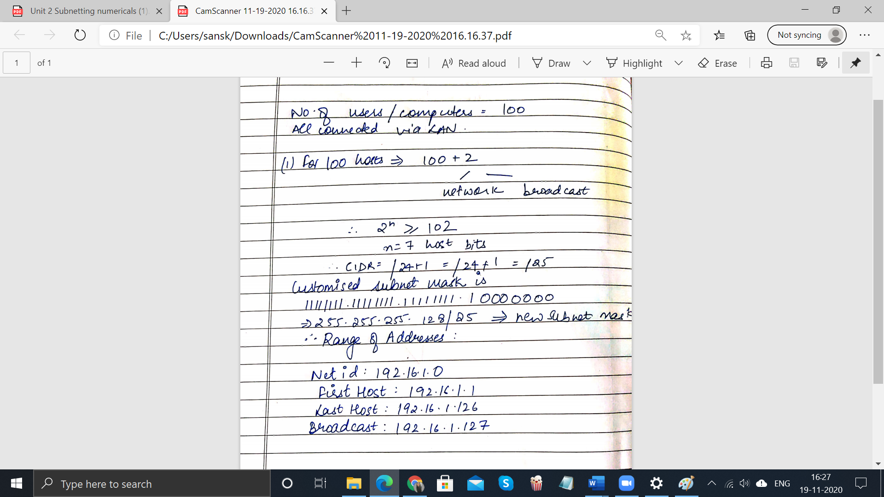

**INFERENCE & CONCLUSION**

Through this project, I have understood the concept of a secure E-commerce network for an organisation. It took more time than expected, but I have tried my best to express what I could comprehend. With this project I could implement the connections, using Cisco Packet Tracer, successfully. This has been designed keeping in mind users have good internet connection & the problems they might face. There might be some minor faults, but I have given this project my full effort. Network connections were implemented appropriately and was done keeping an e-commerce website in mind.

**REFERENCES**

1. <https://www.paessler.com/it-explained/ip-address>
2. <https://bus206.pressbooks.com/chapter/chapter-5-networking-and-communication/>
3. <https://www.quentosity.co.nz/5-essential-e-commerce-security-features-your-website-needs-in-2018/>
4. <https://www.itbriefcase.net/six-essential-requirements-for-a-secure-e-commerce-site>
5. [www.wikipedia.org](http://www.wikipedia.org)